LAB 04: INTRODUCTION TO SUPERVISORY CONTROL AND DATA ACQUISITION (SCADA)
Name: Muhammad Mukhtar Bello
Registration Number: C11/26/ACIS/17371
Course: Intro to Critical Infrastructure for IT Learners
Lab: 04 Introduction to SCADA

1. Introduction
Supervisory Control and Data Acquisition (SCADA) is used in industrial environments to monitor and supervise physical processes. A typical SCADA system collects information from field devices such as sensors and Programmable Logic Controllers (PLCs), presents the information through a Human-Machine Interface (HMI), and provides operators with information about the current state of the process.
In this laboratory exercise, FUXA was used as the SCADA/HMI platform while OpenPLC Runtime was used as the PLC environment. The exercise focused on understanding the relationship between the PLC, industrial communication, and the SCADA interface using a prepared tank-filling simulation.

2. Objective
The objectives of this laboratory exercise were to:
- Understand the purpose and basic architecture of a SCADA system.
- Identify the roles of PLCs, HMIs, alarms, events, and historical data.
- Load and operate a prepared tank-filling HMI project in FUXA.
- Configure communication between the SCADA HMI and OpenPLC Runtime.
- Observe how a PLC-controlled process can be represented through an HMI.

3. Laboratory Environment
The laboratory was carried out using isolated virtual machines in Oracle VirtualBox.
The main components used were:
- PLC VM: OpenPLC Runtime
- SCADA VM: FUXA
- Communication: Industrial network/Modbus TCP configuration
- Process: Tank filling and draining simulation
- HMI Project: TankFillTest.json
The SCADA VM was running FUXA version 1.3.2.

4. Procedure

4.1 Starting the SCADA Environment
The SCADA virtual machine was started and FUXA was launched from the terminal. FUXA reported that the service was already using port 1881, indicating that an instance was already running.
The FUXA editor was accessed through:
http://127.0.0.1:1881/editor
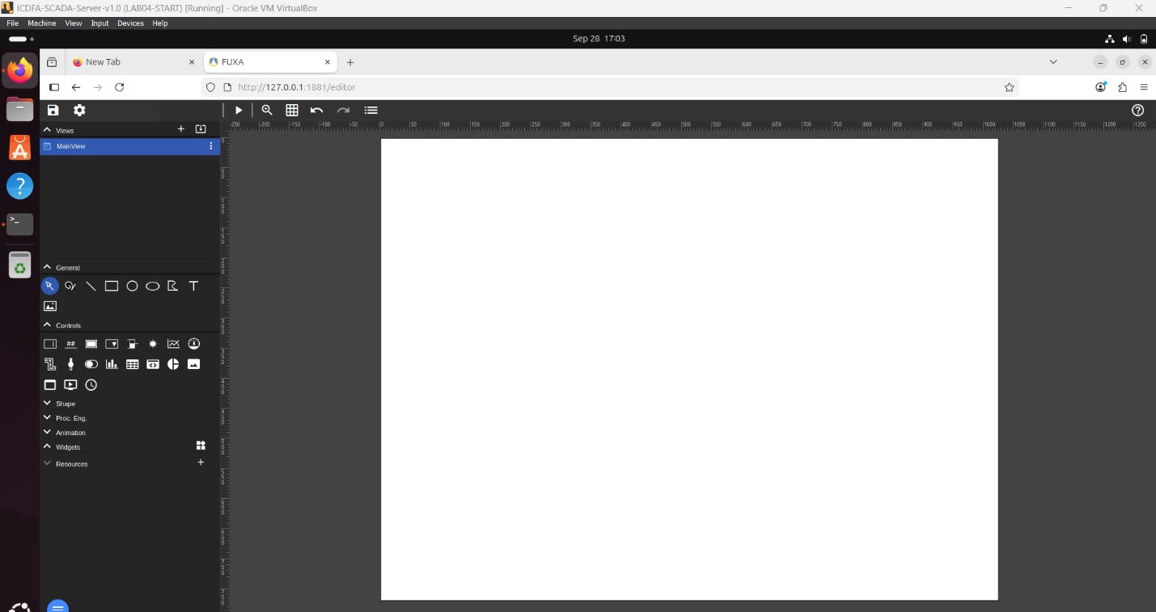
Figure 1 FUXA editor running on the SCADA virtual machine.

4.2 Loading the TankFillTest Project
The prepared TankFillTest.json project was located and loaded into FUXA. After loading the project, the tank graphic and associated HMI elements were displayed successfully.
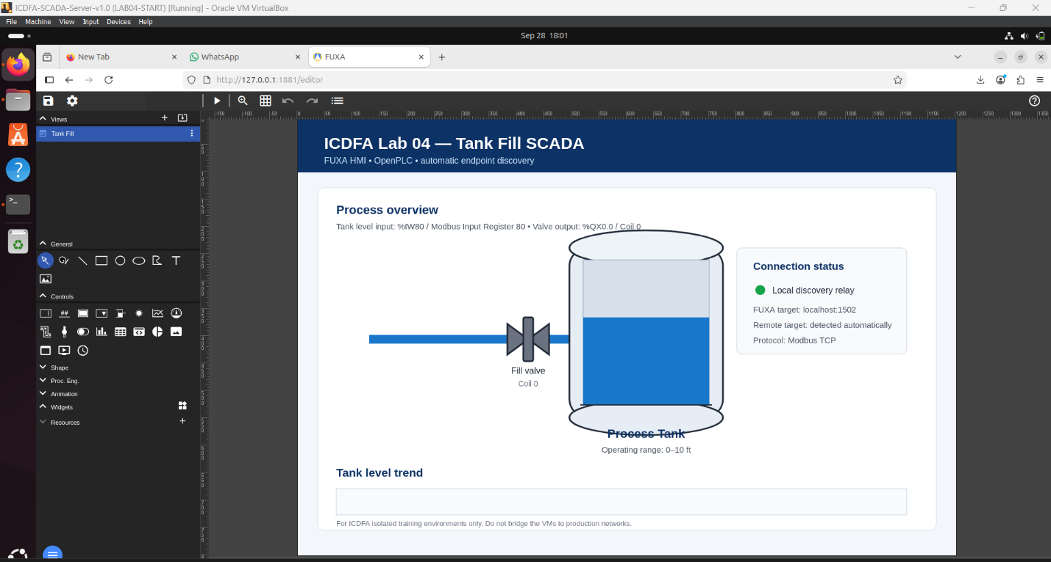
Figure 2 Prepared TankFillTest SCADA/HMI project loaded in FUXA.

4.3 Configuring the SCADA Connection
The FUXA connection settings were inspected to establish communication with the OpenPLC Runtime. The prepared project contained an openplc connection.
The SCADA virtual machine was also checked for its network address. The observed IPv4 address was:
10.0.2.15
The connection configuration was adjusted according to the available FUXA connection settings.

4.4 OpenPLC Runtime
The OpenPLC Runtime web interface was accessed through:
http://localhost:8080/
The TankFillSim.st program supplied with the laboratory exercise was uploaded for compilation.
The original program produced compilation errors related to located variable declarations and Structured Text syntax. The program was then modified to remove the AT %IX and AT %QX declarations while retaining the tank simulation logic.
The modified program generated the following files during compilation:
- POUS.c
- POUS.h
- LOCATED_VARIABLES.h
- VARIABLES.csv
However, compilation subsequently failed because the runtime could not find:
- Config0.c
- Config0.h
- Res0.c
Therefore, the PLC program could not be successfully compiled and started during this laboratory session.
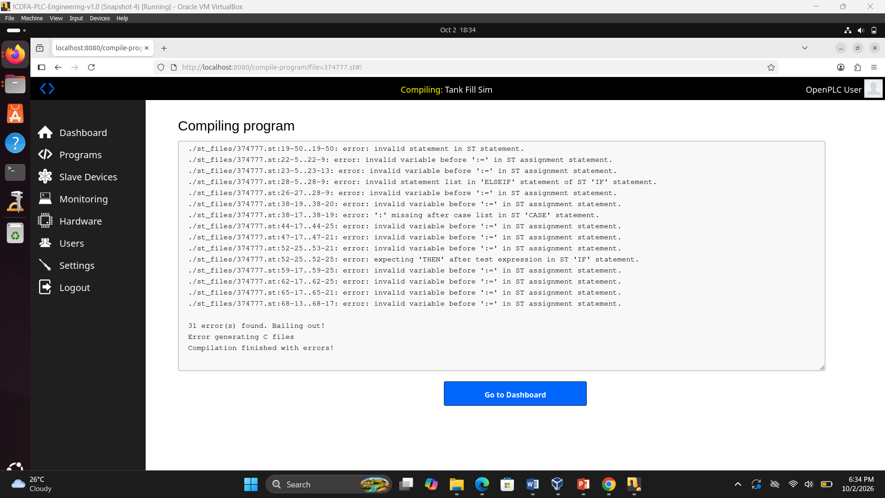
Figure 3 OpenPLC compilation output showing the configuration-file error.

5. SCADA Architecture
The basic architecture of the SCADA system used in the laboratory can be represented as follows:

Figure 4: Basic SCADA architecture showing the relationship between the process, PLC, communication network, SCADA/HMI, and operator.

6. PLC Control Logic and SCADA Visualization
The PLC is responsible for controlling the physical or simulated industrial process. It executes the control logic continuously and determines when outputs such as valves should be activated or deactivated based on inputs and programmed conditions. The PLC therefore performs the actual process control.
The SCADA system performs a different role. It provides a supervisory interface through which an operator can observe the process. Instead of directly executing the main control logic, the HMI presents information received from the PLC in a more understandable form. This can include tank levels, valve states, alarms, trends, and events.
In the tank-filling exercise, the PLC simulation was intended to control the tank level and valve states, while FUXA was intended to display those conditions to the operator. This separation allows the PLC to continue performing control functions while the SCADA system provides monitoring and operator awareness.

7. Alarms, Events and Historized Data
An alarm is an indication that a process condition requires operator attention. For example, a high tank level could generate a high-level alarm.
An event records that something happened in the system, such as a valve being opened, a PLC being started, or an operator action occurring. Events do not necessarily indicate an abnormal condition.
Historized data refers to process information stored over time. For example, storing tank-level measurements allows an operator to view a trend showing how the tank level changed during operation.
These functions provide more useful information than displaying raw sensor values alone.

8. Importance of Context in SCADA
Operators require context because raw sensor values do not always clearly indicate the condition of a process. For example, a tank-level value of 90% has more meaning when the operator can also see whether the filling valve is open, whether a high-level alarm is active, and whether the level is increasing or decreasing.
SCADA therefore combines process values with visual indicators, alarms, trends, and status information. This allows operators to understand the state of the process more effectively and respond appropriately.

9. Knowledge Check

1. What is the purpose of an HMI?
An HMI provides a graphical interface through which an operator can monitor and interact with an industrial process. It presents information such as process values, equipment status, alarms, and trends.

2. What is the difference between an alarm, an event, and historized data?
An alarm indicates that a process condition requires attention. An event records that a particular action or occurrence happened. Historized data stores process measurements or states over time so that they can later be reviewed or displayed as trends.

3. Why does an operator need context rather than raw sensor values?
Context helps the operator understand what a sensor value means in relation to the overall process. Information such as equipment status, alarms, trends, and operating conditions makes the displayed value more useful for monitoring and decision-making.

4. What is the role of the PLC compared with the SCADA application?
The PLC performs real-time process control by executing programmed control logic and operating outputs. The SCADA application provides supervisory monitoring and visualization of the process and presents information to the operator.

10. Result and Observation
The FUXA SCADA environment was successfully started and the prepared TankFillTest.json HMI project was loaded and displayed.
The OpenPLC Runtime was also successfully accessed. However, the supplied TankFillSim.st program could not be compiled successfully in the installed OpenPLC environment. After resolving the initial Structured Text errors, the compiler reported missing Config0.c, Config0.h, and Res0.c files.
As a result, a live PLC-to-FUXA tank simulation could not be demonstrated during this session. The limitation was recorded rather than presenting simulated results as actual observations.

11. Conclusion
This laboratory provided practical exposure to the basic architecture and purpose of SCADA systems. FUXA was used to load and inspect a prepared HMI project, while OpenPLC Runtime provided the PLC environment intended to control the tank simulation.
The exercise demonstrated the distinction between PLC control and SCADA supervision. The PLC is responsible for executing process-control logic, while the SCADA/HMI provides visualization and operator awareness through process values, equipment states, alarms, events, and trends.
Although the live PLC-to-FUXA simulation could not be completed because of compilation and project-configuration errors in the OpenPLC environment, the SCADA environment and prepared HMI project were successfully accessed and examined.

